PROGRAM
import cv2

def save_video(speed, output_name):
cap = cv2.VideoCapture("sample.mp4")

if not cap.isOpened():
print("Video not found! Check sample.mp4")
return

fps = cap.get(cv2.CAP_PROP_FPS)
width = int(cap.get(cv2.CAP_PROP_FRAME_WIDTH))
height = int(cap.get(cv2.CAP_PROP_FRAME_HEIGHT))

if fps <= 0:
fps = 30

output_fps = fps * speed

if speed == 2:
output_fps = fps

fourcc = cv2.VideoWriter_fourcc(*"mp4v")
out = cv2.VideoWriter(
output_name, fourcc, output_fps, (width, height)
)

frame_count = 0

while True:
ret, frame = cap.read()

if not ret:
break

if speed != 2 or frame_count % 2 == 0:
out.write(frame)

frame_count += 1

cap.release()
out.release()

print(output_name, "saved successfully!")

save_video(1, "normal_speed.mp4")
save_video(0.5, "slow_motion.mp4")
save_video(2, "fast_motion.mp4")

print("All output videos created successfully!")

OUTPUT
The program generates the following video files:
1.Normal_speed.mp4 – Video played at normal speed.
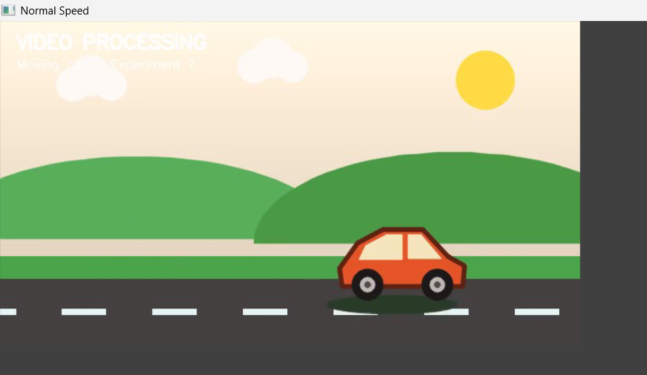
2. slow_motion.mp4 – Video played at half speed.
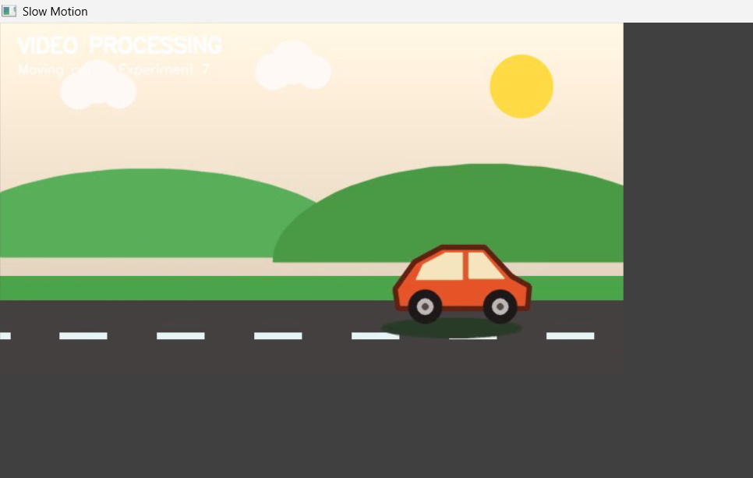

3.fast_motion.mp4 – Video played at approximately twice the speed.
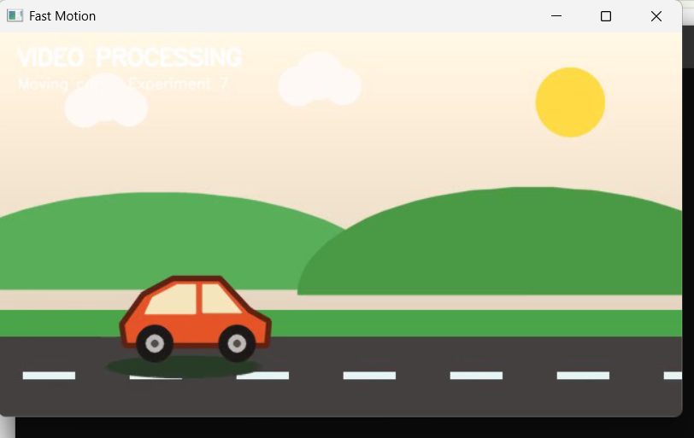

RESULT
Thus, the captured video was read and processed using Python and OpenCV. The video outputs for normal motion, slow motion, and fast motion were generated and saved successfully.

